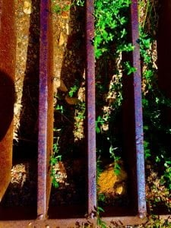
Photo by joe
I like this picture because it has a lot of colors, and it takes up the whole frame.
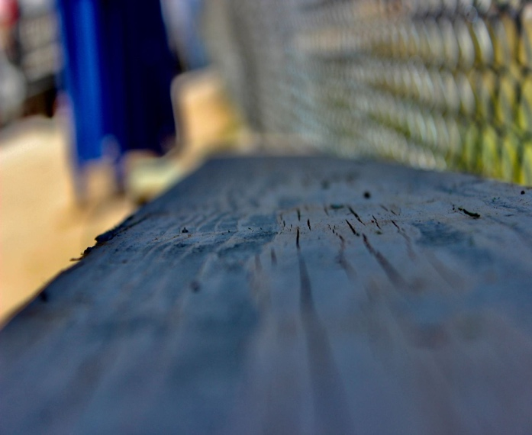
Photo by Taye
I like this photo because the background is blurry, and it looks cool and i can see the cracks in the wood.
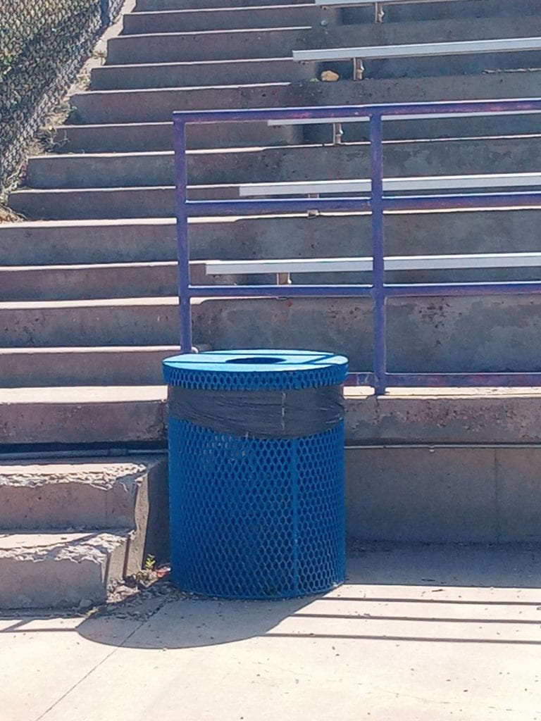
Photo by Gabe
I like this photo because there a lot going on in the photo and not just the shape.

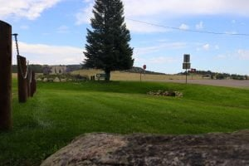
Photo by Kenzie
I like this photo because there's a lot of stuff going on in the photo and some stuff is close and some is far.

